Steps to Extending a Fiori Element App:
1>Locate the APP ID.
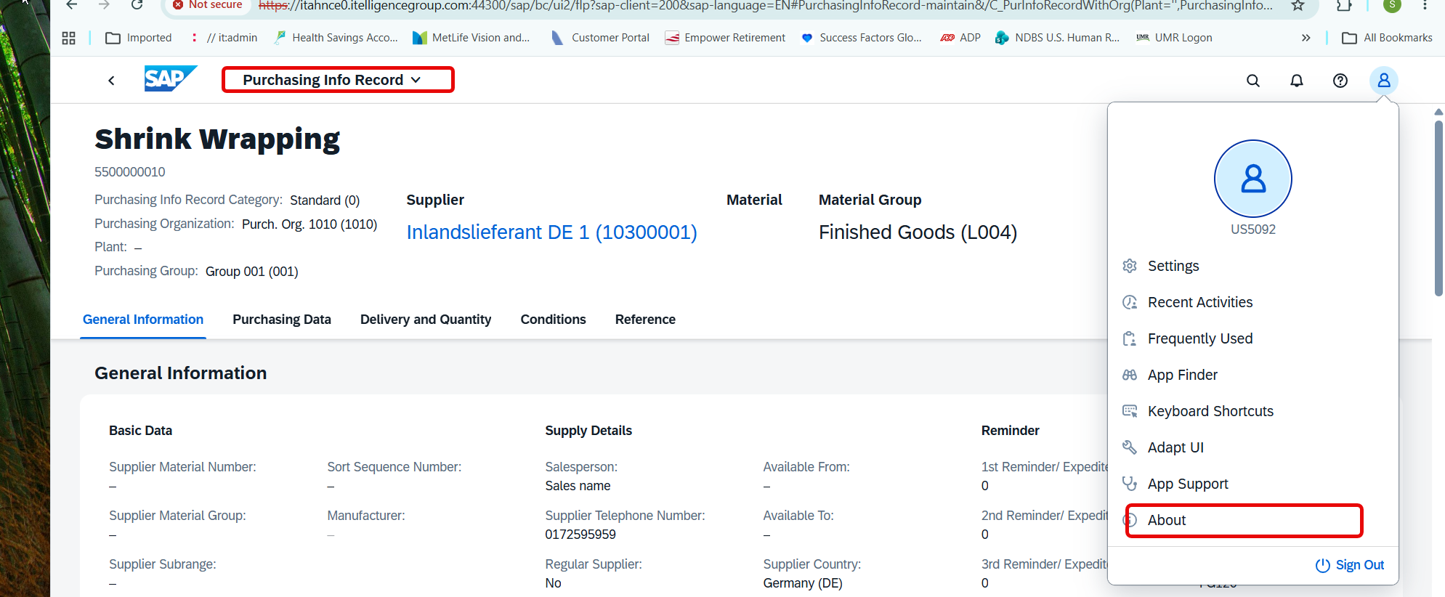

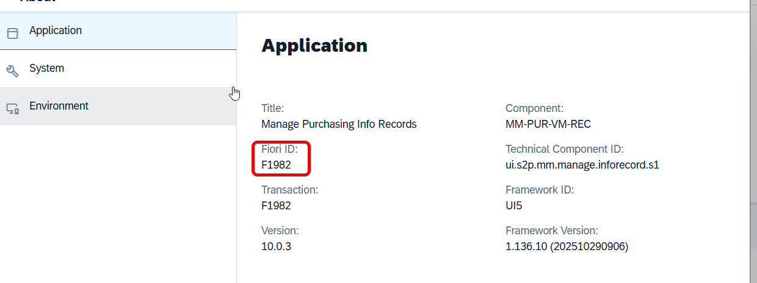
2> Go to SAP library
https://fioriappslibrary.hana.ondemand.com/sap/fix/externalViewer/#/detail/Apps('F1982')/S32PCE
Now look for the UI5
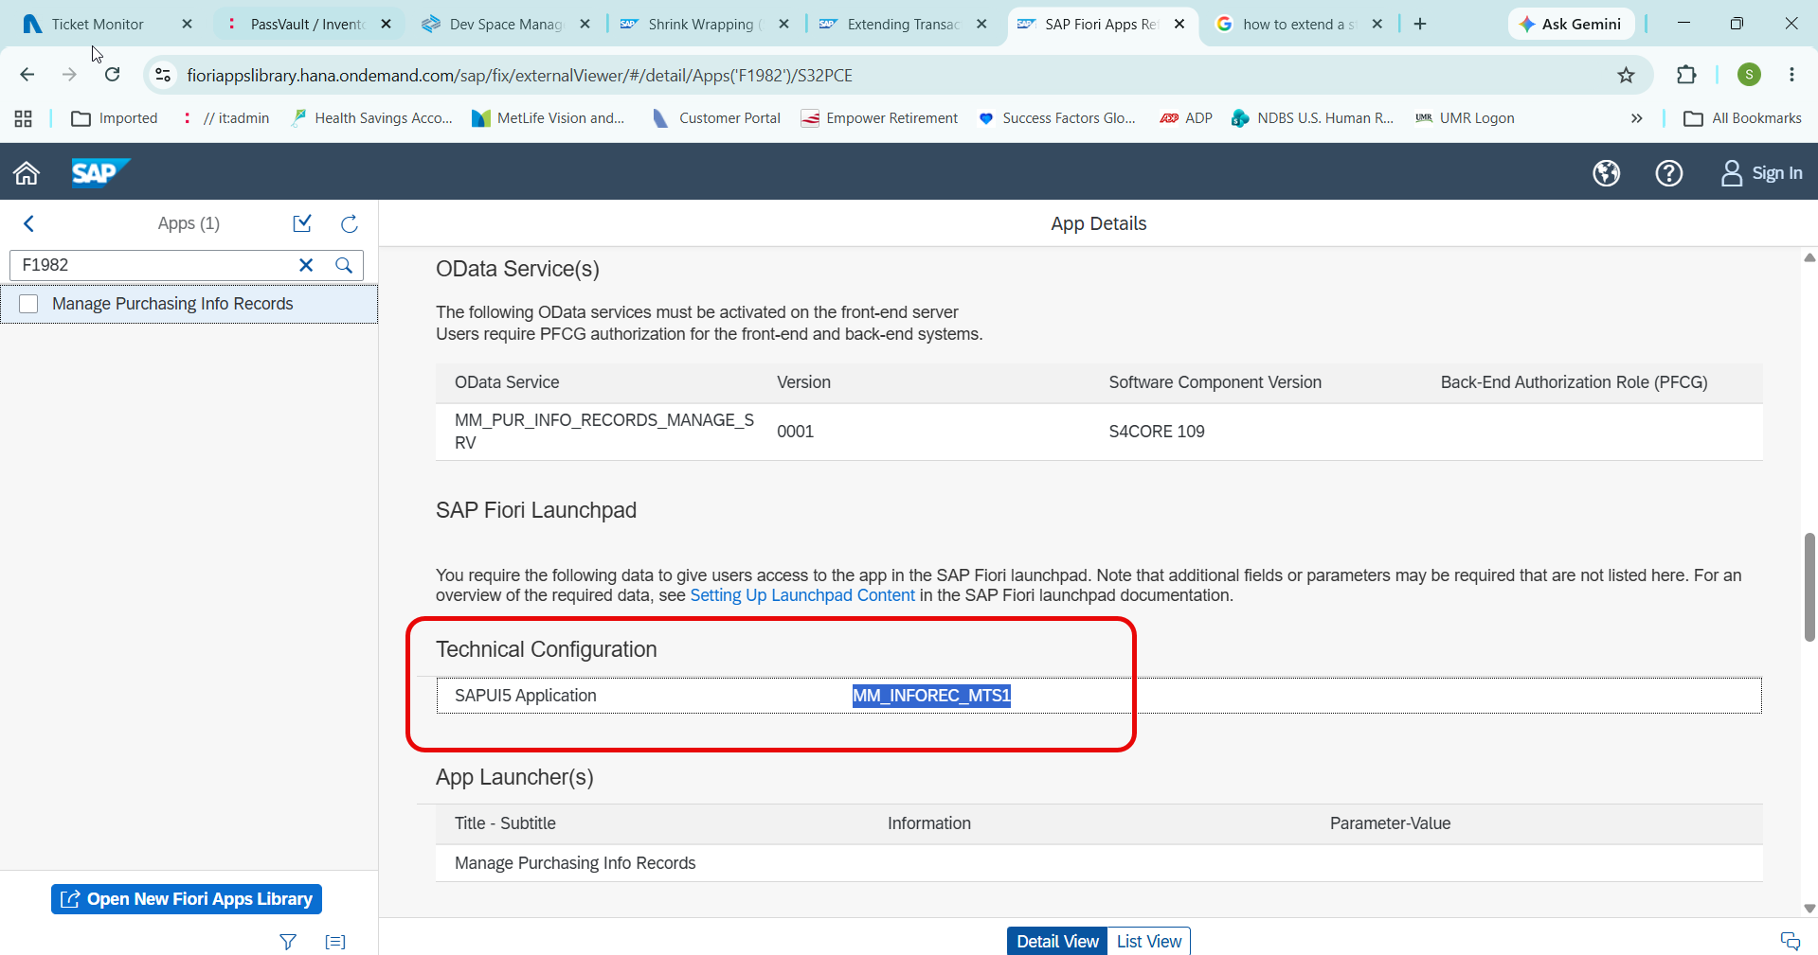

Once you have located the Application, Also look for the Odata service.
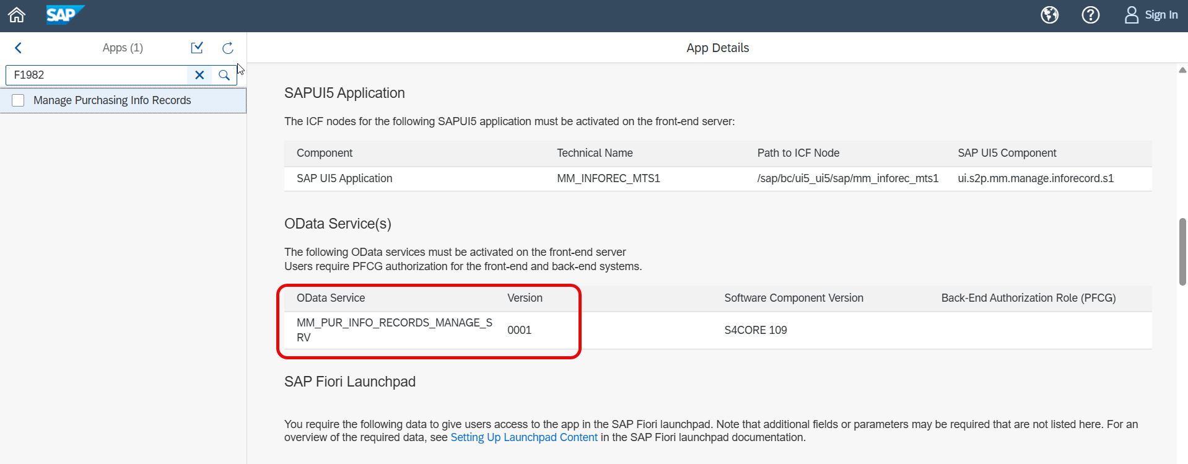

To Investigate further.
Open up the BSP application on SE80.
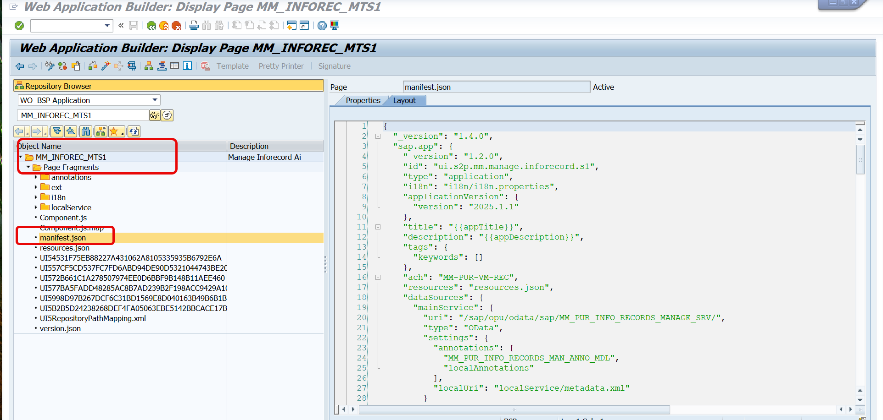

Review the Manifest.json to find the CDS view that is used for consumption.
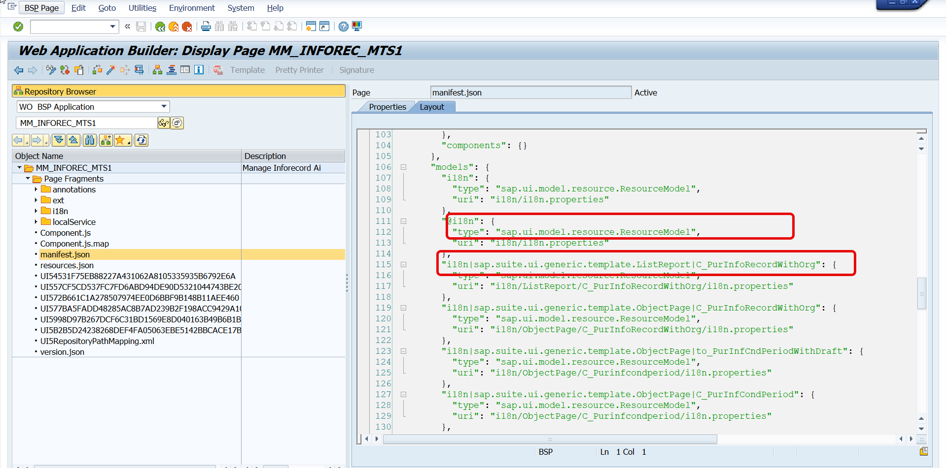

This should take you to the following CDS view in Eclipse. This is what the BSP app is using as the data source.
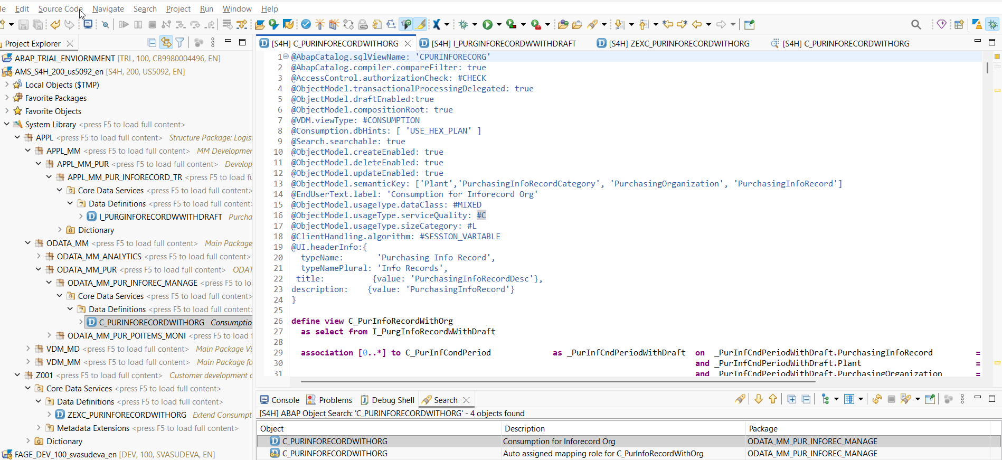
In order to add additional fields, We can extend the Consumption view or if needed we may have to extend a lower level Interface view to add additional fields for the Consumption view to use.
In this case I am going to add the Supplier country and Production Version.
First to add the Supplier Country I will be able to extend the Consumption view C_PurInfoRecordWithOrg with the additional field.
Start by creating a new data definition by right clicking the view.
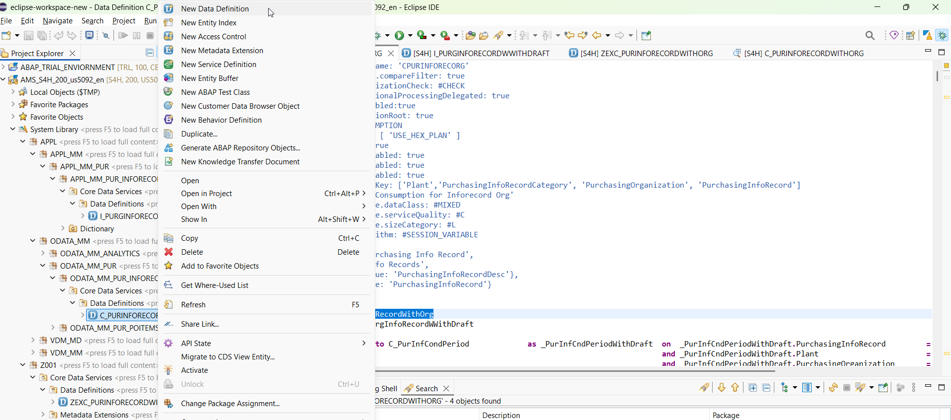

@AbapCatalog.sqlViewAppendName: 'ZSQL_APPEND_NAME'
@EndUserText.label: 'Extension for Standard View'
extend view C_PurInfoRecordWithOrg with ZEXC_PURINFORECORDWITHORG
association [1..1] to I_CountryVH as _SupplierCountry on $projection.SupplierCertOriginCountry = _SupplierCountry.Country
{
@UI: { identification: [{ position : 8 , importance: #HIGH}],
fieldGroup:[{qualifier: 'Supply Details', groupLabel: 'Supply Details', position: 8, importance: #HIGH } ]
}
@EndUserText.label: 'Supplier Country'
@ObjectModel.readOnly: true
@ObjectModel.text.element: [ 'Description' ]
@Consumption.valueHelp: '_SupplierCountry'
I_PurgInfoRecordWWithDraft.SupplierCertOriginCountry as SupplierCertOriginCountry,
@ObjectModel.readOnly: true
_SupplierCountry.Description as Description,
_SupplierCountry
}

After Adding this code and activating, I have the Supplier Country now on the app.
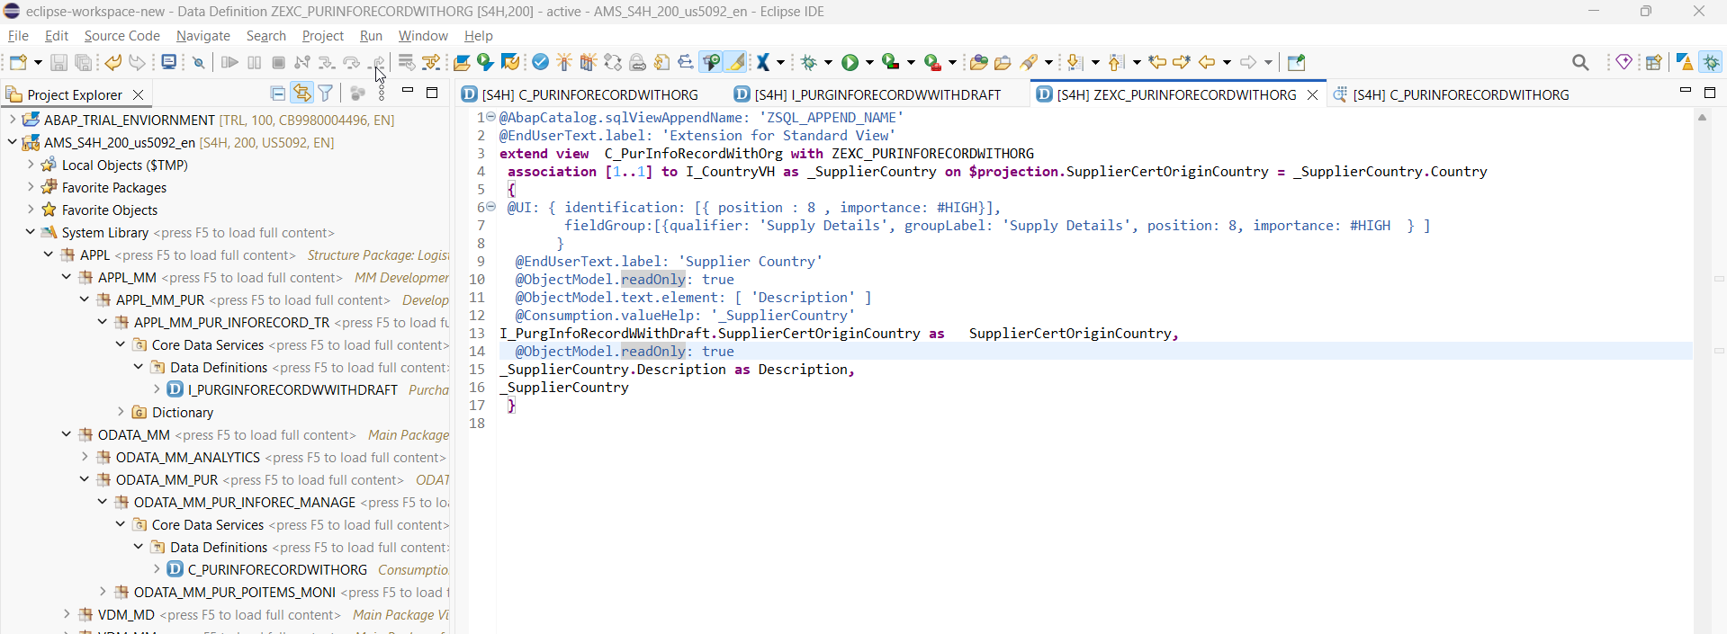
Result:
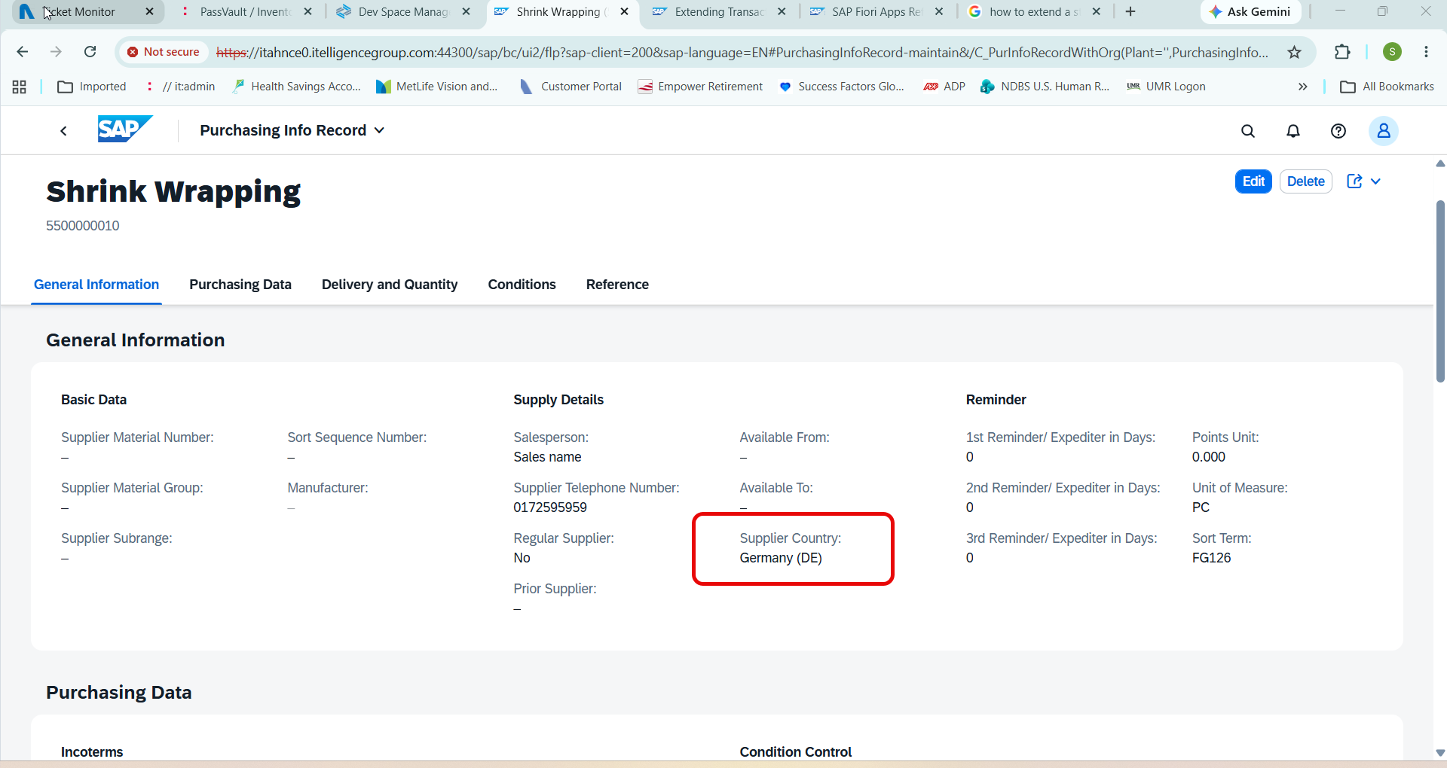
Now I want to add further the following fields from Supplier BP.
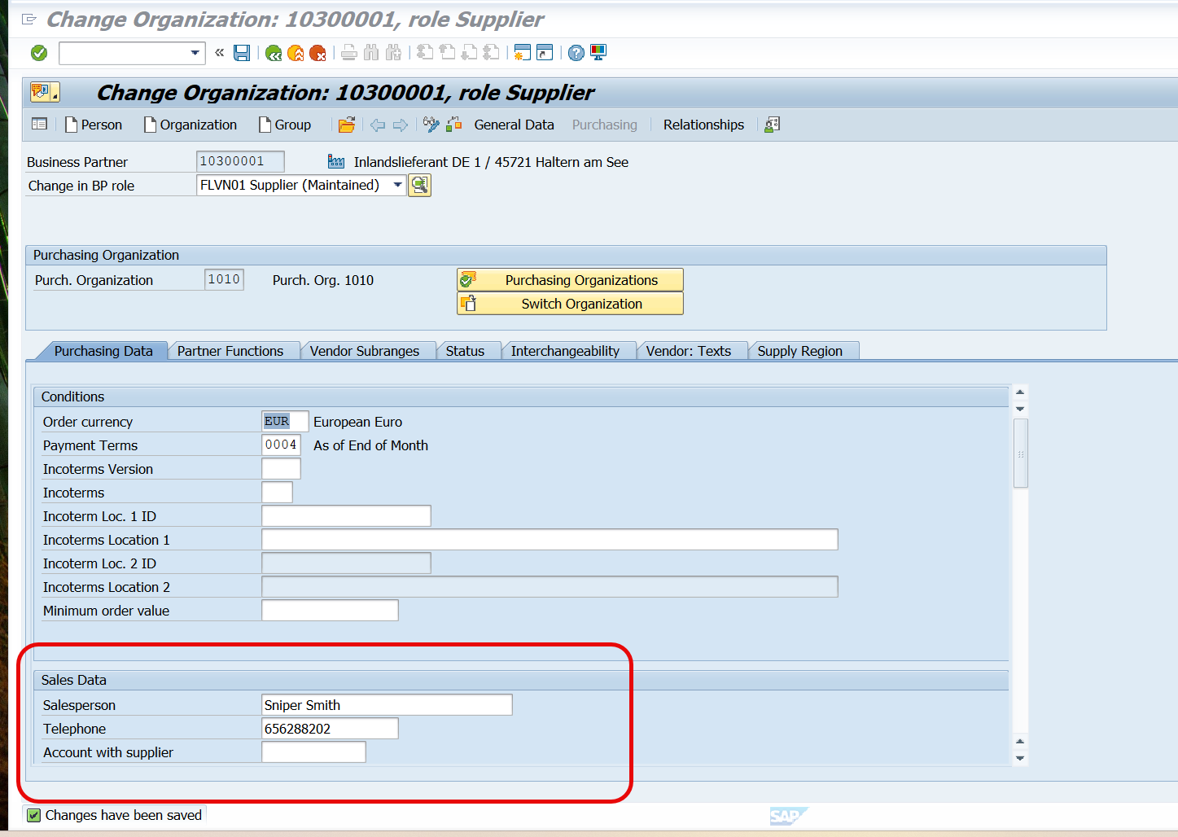
SalesPerson at Vendor and Telephone number

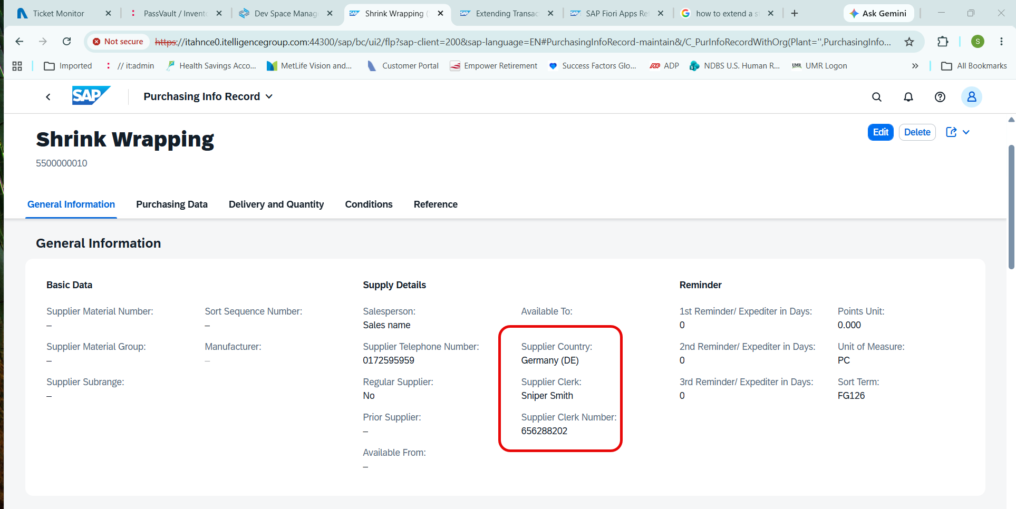

@AbapCatalog.sqlViewAppendName: 'ZSQL_APPEND_NAME'
@EndUserText.label: 'Extension for Standard View'
extend view C_PurInfoRecordWithOrg with ZEXC_PURINFORECORDWITHORG
association [1..1] to I_CountryVH as _SupplierCountry on $projection.SupplierCertOriginCountry = _SupplierCountry.Country
association [1..1] to I_SupplierPurchasingOrg as _SuppPurchOrg on $projection.supplier = _SuppPurchOrg.Supplier
and $projection.purchasingorganization = _SuppPurchOrg.PurchasingOrganization
{
@UI: { identification: [{ position : 8 , importance: #HIGH}],
fieldGroup:[{qualifier: 'Supply Details', groupLabel: 'Supply Details', position: 8, importance: #HIGH } ]
}
@EndUserText.label: 'Supplier Country'
@ObjectModel.readOnly: true
@ObjectModel.text.element: [ 'Description' ]
@Consumption.valueHelp: '_SupplierCountry'
I_PurgInfoRecordWWithDraft.SupplierCertOriginCountry as SupplierCertOriginCountry,
@ObjectModel.readOnly: true
_SupplierCountry.Description as Description,
_SupplierCountry,

@UI: { identification: [{ position : 9 , importance: #HIGH}],
fieldGroup:[{qualifier: 'Supply Details', groupLabel: 'Supply Details', position: 9, importance: #HIGH } ]
}
@EndUserText.label: 'Supplier Clerk'
@ObjectModel.readOnly: true
_SuppPurchOrg.SupplierRespSalesPersonName as SupplierClerk,

@UI: { identification: [{ position : 10 , importance: #HIGH}],
fieldGroup:[{qualifier: 'Supply Details', groupLabel: 'Supply Details', position: 10, importance: #HIGH } ]
}
@EndUserText.label: 'Supplier Clerk Number'
@ObjectModel.readOnly: true
_SuppPurchOrg.SupplierPhoneNumber as SupplierClerkNo,
_SuppPurchOrg
}

